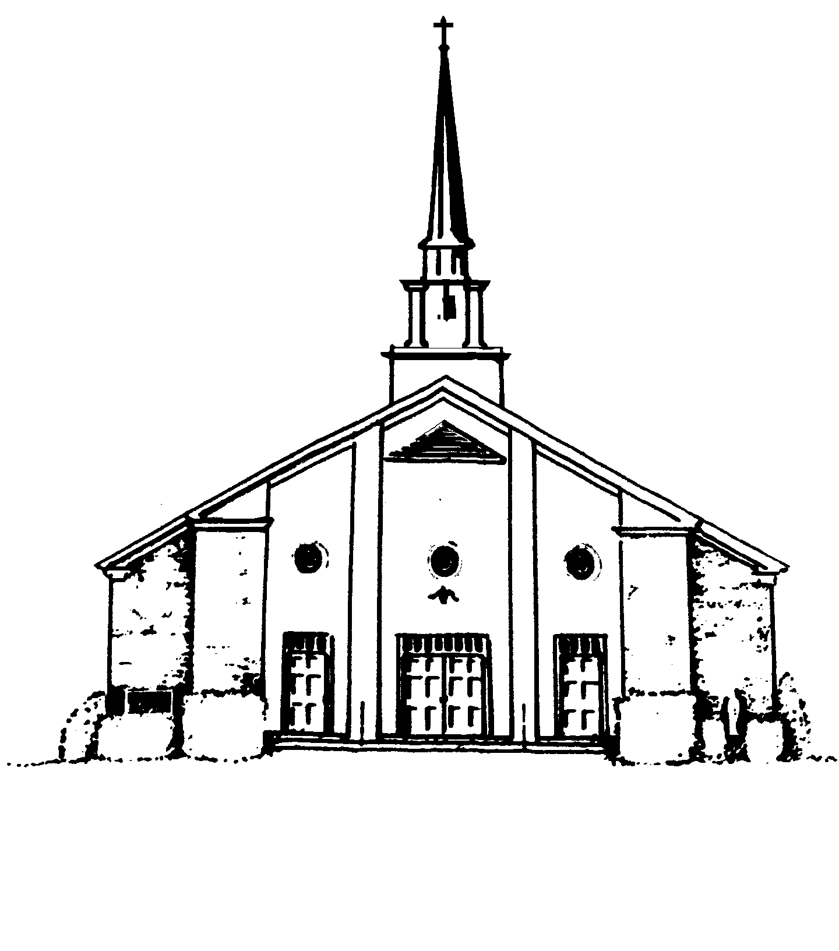
Notre Dame of Easton
Office of Religious Education
655 Morehouse Road
Easton, CT 06612-1334
(203) 261-5596 voice
(203) 459-4940 facsimile
ndore@optonline.net
May 15, 2019
Dear Parents:

As we prepare for the 2019-2020 Religious Education Program year we want to thank you for your continued support of your children as they are formed in the Catholic faith and grow in their relationship with Jesus Christ. Parents have the primary responsibility of raising their children in the faith and are
the best teachers. It is a privilege for us to assist you as you hand on the faith to this generation.

Attached are the forms to register your children for the 2019-2020 Religious Education Program at
Notre Dame of Easton. To returning families “Welcome back”. To families new to the program: “Welcome” and we look forward to meeting you.

Please read this letter carefully since it details several aspects of the Religious Education Program
and the registration process. If you have a child to register who is not listed on the pre-printed form
that is included with this letter, please add the complete information for that child in any blank space on
the front of the form.

To register for the 2019-2020 academic year, please return the corrected/completed registration form,
the completed supplemental information form and a check for the total amount payable to “Notre Dame
of Easton” before July 1, 2019. (We will not accept online payments this year.) Your child will not be registered until both forms are received and all tuition and fees, including late fees if applicable, are paid in full. If payment is received after July 1, 2019 for either the home-schooling or classroom Religious Education program, a late fee of $30 per child will be added to tuition due. After August 1, 2019, the late fee is $50 per child and after September 1, 2019, the late fee is $75 per child.

Tuition for the 2019-2020 academic year for grades 1 through 8 is $200.00 for the first child, $300.00 for two children and $375.00 for three or more children. Tuition is the same for either the home-schooling or the classroom programs. There is a Sacramental fee of $75 for second grade students who will receive the Sacrament of First Reconciliation and a Sacramental fee of $75 for third grade students who will receive the Sacrament of First Holy Communion.
The fee for grade nine pre-Confirmation retreats, workshops, materials and robe rental is $175.00.
This is the only fee for students who will receive the Sacrament of Confirmation in the fall of 2019. There is no tuition cost.

Registration will not be complete until all tuition and fees, both current and outstanding, are paid in full, or other arrangements have been established with the Director. Tuition and fees do not cover program costs and the parish subsidizes the program. Tuition aid is available and confidential for any family needing assistance who meets the Diocese and Parish criteria. We are in need of volunteers to teach - tuition is waived for the children of teachers, however, sacramental fees still apply.

As we assemble each class:
1) First priority will be given to the children of teachers, then to registered, active, contributing,
Parishioners of Notre Dame;
2) Second priority will be given to registered, active members of other Catholic parishes;
3) Third priority will be all other individuals.

Classes will be held to a maximum of 15 students per class. Once we fill the classes, those not assigned to a class will be placed on a waiting list and/or will be offered home-schooling.

If your child received the Sacraments of Baptism, First Reconciliation or First Holy Communion at a parish other than Notre Dame, you must be provide us with copies of the signed Certificates validating the reception of each of these Sacraments. Registration will not be completed without these documents.

The registration form that you have received is computer generated and presumes that your child(ren) has satisfactorily completed his or her prior grade in the Notre Dame of Easton Religious Education program during the 2019-2020 academic year, and shows that child as being advanced to the next grade level. If a deficiency exists however, i.e. incomplete home-schooling, the advancement will not be complete and the student will not be registered for the next grade until all requirements have been satisfied. A parent’s signature must be shown on the registration form that is returned to the Religious Education office. The parent’s signature is necessary to prove registration to our insurance carrier, to grant permission for your child to attend Religious Education and also to identify relevant parental permissions. The parent’s signature gives us permission to provide your child’s catechist with the family’s home address, telephone number and e-mail address. This information may also be used, with the permission of Father Lyons, to notify your family about Parish related functions.

If you have questions regarding the registration process, please contact the Office of Religious Education during office hours at 203-261-5596 or by email at ndore@optonline.net.

God Bless you and your family.

Fr. Michael P. Lyons, Mrs. Patricia Steccato,
Pastor Director of Religious Education

